Before I went to London, I read the book Longitude. The book was about John Harrison and his quest to solve “the longitude problem”. Nobody in the 18th century was able to tell longitude which meant ships were getting lost at sea. Many lives were lost due to this issue, so there was a grand prize available to whoever could solve the longitude problem. Harrison spent 40 years exploring and building chronometers to keep time. Today he is credited with figuring out how to track longitude with his precise clocks which are displayed at the National Maritime Museum.

During our trip to London, we got the opportunity to go to Greenwich and visit the National Maritime Museum. It was really interesting to see the exact clocks that I had previously been reading about. Below are some pictures that I took of the National Maritime Museum.

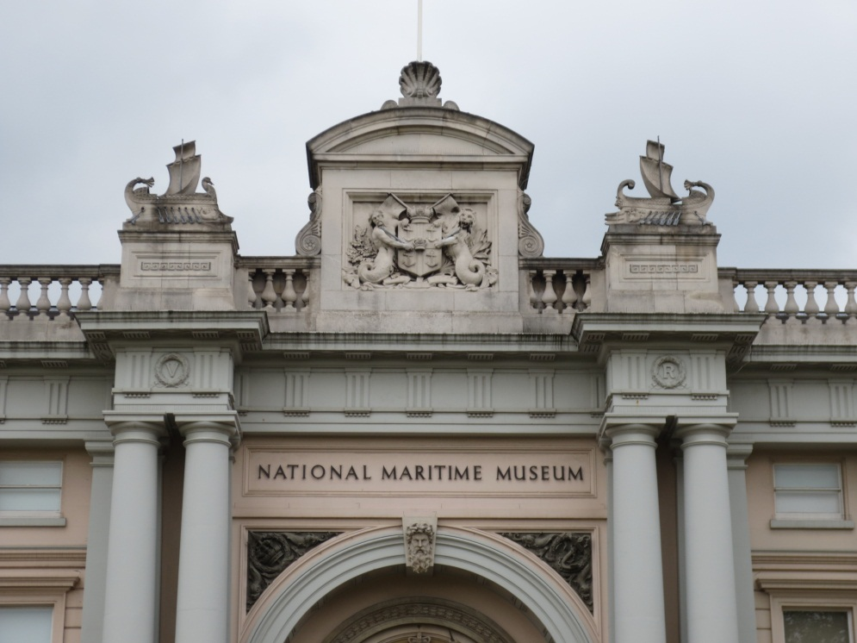

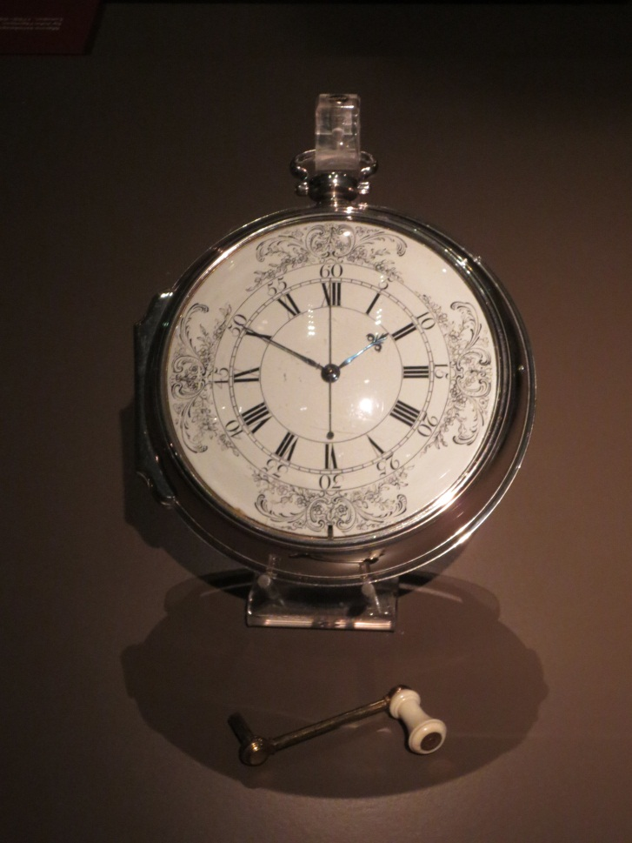

John Harrison and Longitude have greatly impacted the world today. It is because of his hard work and discovery of longitude that we are now able to travel overseas without getting lost. We are now able to track north, south, east and west. Personally, I didn’t realize how much this affected the world until I was able to actually see the clocks. I now understand why they took so long to build as they are very detailed and large. It is amazing that one could figure out to build something so precise. It is still seen today with technology. New items are invented very often these days and updated just as much. Scientists are still rewarded and recognized as they were in the 18th century.

It was a good experience to visit the National Maritime Museum in Greenwich. It definitely helped me connect to book to real everyday life.

Another place I was able to visit while in London was Dr. Jenner’s House which is located in Berkeley. This was a museum in the home of Edward Jenner who was the scientist that invented vaccines. Jenner invented the smallpox vaccine that saved any lives and eventually eradicated the disease. His work led to the idea of immunology. I found this museum very interesting because before this trip we were required to read a book called Dr. Jenner and the Speckled Monster. This book was very informative about how Jenner created the vaccine that saved many lives. The museum and the book tied together very well and it was an interesting matter to learn about. Below are some pictures I took at the Jenner museum.

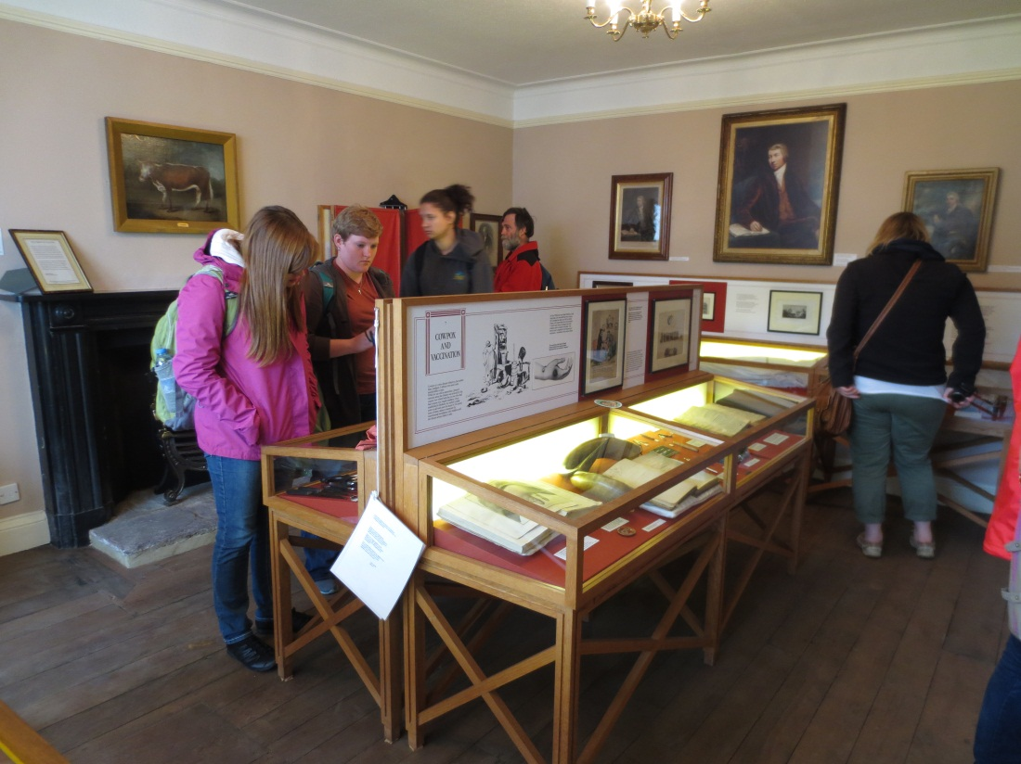

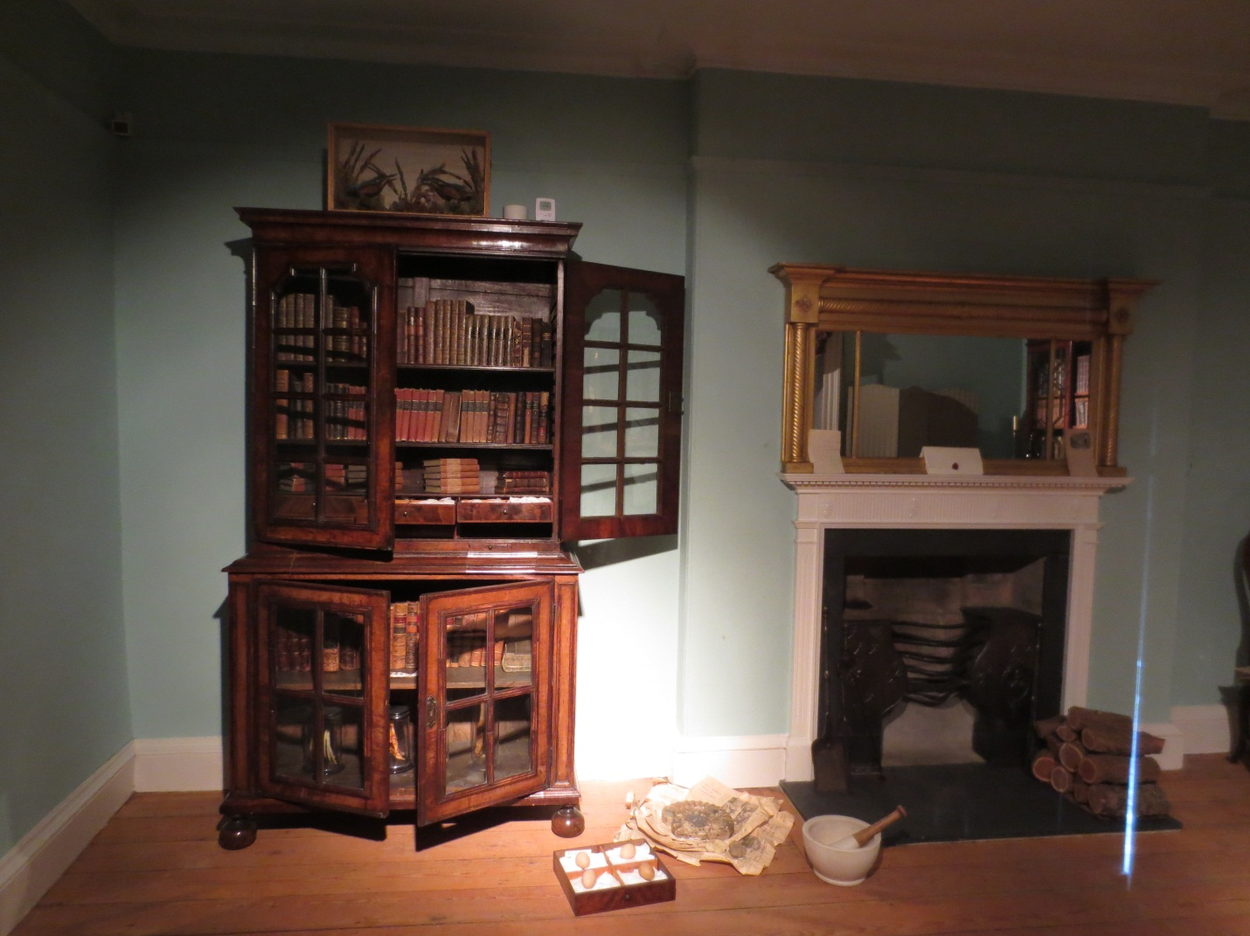

Jenner studied and experimented very much to find a way to stop smallpox from spreading further. Today many scientists are still working just as hard to figure out cures for cancer, AIDS, etc. It was very exciting to be able to visit Dr. Jenner’s museum and see where all of his hard work and experiments took place.

