TRACKING EARTHQUAKES USING GOOGLE EARTH

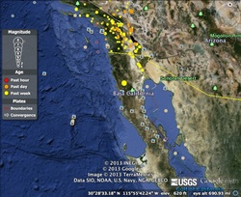
Magnitude: 4.0
Location: 31.225_N, 115.913_W Region: BAJA CALIFORNIA, MEXICO
Date: Thursday, April 04, 2013
Time: 8:30 AM
Depth: 5 Km (3.1 miles) (poorly constrained)
Tectonic Boundary: This earthquake occurred near a ‘transform’ tectonic plate boundary.

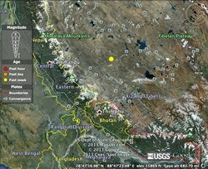
Magnitude: 4.7
Location: 30.094_N, 88.081_E Region: WESTERN XIZANG
Date: Saturday, April 06, 2013
Time: 2:36 AM
Depth: 34.7 km (21.6 miles)
Tectonic Boundary: The Himalaya’s are the best example of a convergent, ‘continental-continental’ plate boundary. These mountains grow, on average, about a quarter of an inch per year.

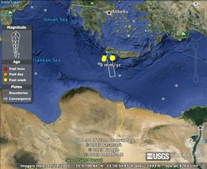
Magnitude: 5.3
Location: 34.889_N, 24.085_E Region: CRETE, GREECE
Date: Saturday, April 06, 2013
Time: 2:26 PM
Depth: 35 km (21.7 miles)
Tectonic Boundary: I think this is a ‘divergent’ earthquake because it happened near the Red Sea. The Red Sea was created as the African and Arabian plates separated, and this quake seems near enough that particular fault line to make me believe it is related to the shifting of those two diverging plates.

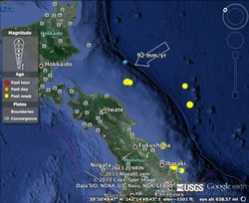
Magnitude: 5.2
Location: 39.551_N 143.234_E Region: OFF THE COAST OF HONSHU, JAPAN
Date: Tuesday, April 02, 2013
Time: 12:08 PM
Depth: 20.3 km (12.6)
Tectonic Boundary: In ‘oceanic-oceanic’ plate boundaries there is often a volcanic chain offshore. Japan and the Aleutian Islands seem to me to be great example of this.

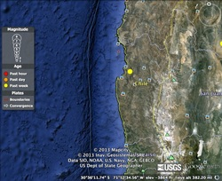
Magnitude: 4.8
Location: 30.102_S, 71.213_W Region: COQUIMBO, CHILE
Date: Monday, April 8, 2013
Time: 4:50 AM
Depth: 69.9 km (43.4 miles)
Tectonic Boundary: With the Andes mountains right along the coast line, this seems to me to be an ‘oceanic-continental’ plate boundary.

